# Online teacher application form: quick reference guide

Teacher applicants are now able to submit their Application for Teacher Employment and upload supporting documentary evidence online through the [Teach Queensland website](http://www.teach.qld.gov.au). When submitting your application please make sure you provide all required attachments to ensure we are able to process your application in a timely manner so you are ready to start your teaching career in a Queensland state school.

Teacher applicants are only to apply once online. If you have already submitted an application and need to make some amendments or supply additional supporting documentation, contact us by email at [teacherapplications@qed.qld.gov.au](mailto:teacherapplications@qed.qld.gov.au) with your name in the subject line.

Please ensure you are using Internet Explorer or Google Chrome as your browser as our form is not compatible with Safari or Firefox.

## Before you begin: Complete your application form and scan all supporting documents

Certified copies of all documentary evidence are required. Certification must be by an authorised person such as: School Principal or their nominee, Human Resource personnel from a departmental regional office, a Justice of the Peace, a Commissioner for Declarations or a solicitor.

## Complete the contact details

Complete all of the mandatory fields marked with an asterisk 

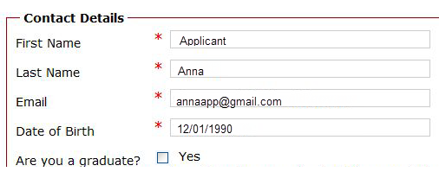

## Upload your saved and completed application for teacher employment form

Click the Browse button to locate your saved application form.

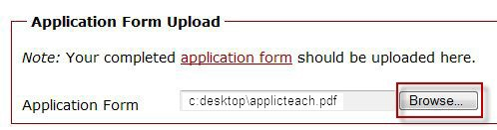

## Upload your supporting documentary evidence

Supporting documentation includes certified copies of your birth certificate, passport, academic statements and degrees, QCT registration certificate and any other documents required.

**Acceptable formats** are: Adobe PDF (.PDF), Microsoft Word (.DOCX, DOC) and graphic files (JPG, GIF and PNG). An error message will appear if the file is an unexpected format. Please resave the document in an accepted format and upload again.

**Up to 9 documents** can be attached.

Total combined file upload **must not exceed 20 MB**.

Click the Browse button to locate the saved copies of your supporting documentation.

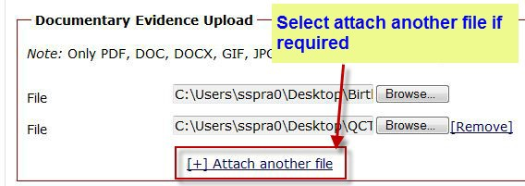

To add additional files select the Attach another file link. 



To remove an unwanted file, select the Remove link.

## Submitting confidential information for YES responses to employment screening questions

## If you answer YES to any of the employment screening questions about criminal history, investigations or disciplinary outcomes you need to separately provide information by email to teacherrecruit.HR@qed.qld.gov.au . Your information will remain confidential and not provided to Principals or schools.

## Submit your application

Submit your application by selecting the Submit button.

If your application has been successfully uploaded you will have the following message on screen.

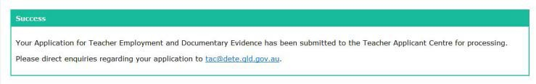

An email confirming your application has been received will also be sent to the email address you entered in the contact details.

## Further assistance

If you have any enquiries regarding the form, need to make updates, or you have received an unexpected error message on the submission of the form, please contact us by email [teacherapplications@qed.qld.gov.au](mailto:teacherapplications@qed.qld.gov.au) or phone 1300 TEACHING (1300 832 244)